About Me:

My name: Khairi Abdallah Alaswad

I have two Children (Girl and boy)

I am living in Stretford in Manchester

My background:

I was working as Electrical Engineer for Oil company

I worked for a few charities, such as Manchester Shopmability

I am speaking two languages: Arabic and English

Interests in technology and coding:

As I mentioned about previous job as electrical engineer, I could not do it anymore because of disability I have. Therefore, I needed to learn and update my knowledge to have a chance for another job.

Moreover, I like to have new challenges with computer specific with programming and creating websites

Besides it is job I can do, any time and everywhere.

Consequently, I became very interested in joining Code Nation to help me achieve my dream

Activity (2)

There are eight pages

Yes each page has a separate HTML but there is one css stylte for all

IT tools I used to complete the project there were THML, CSS to control project style

And 8 visual studio files for each code main page (index), A bout me page, and page for each unit and outcomes. Therefore, I have needed also to use Trello to make cards for (things we need to do, doing, and done), draw.io (to draw flow diagram for web pages) and everything we looked-for, such as google, books and so on.

2.2 the IT tools there were very useful and helpful to finish our project.



this software is a phenomenal tool, gave me a good time to manage my work with a team on python and more on my website project, easy to use and organise the project of a whole team or just want to boost your own productivity. It can use it in any area of the business, from software development and UX testing to marketing and design.



Visual Studio includes a lot of flexible tools to build modern web applications and websites. Besides the Microsoft application development with ASP.NET, it can be use almost any other programming language, such as JavaScript, Node.js, Python, etc. Microsoft Visual Studio is an excellent rapid application development

2.3 the project:

|  |  |
| --- | --- |
| Strengths | weaknesses |
| Videos background | Some page the buttons needs more |
| Semple | The sound of the videos dose not come out you cannot receive the music |
| Happy |  |
| Satisfied |  |

Happy because the first project I have did (webpage), for me it is life change a new career and direction

However, there are some points I am not happy with it, because I believe I can do better, and I will try my best do give myself chance to make more progress in this field

2.4 For this time, I think this is it, for making project like this one (webpage), further improvement I need to make this project better it is spending more time studying and searching online.

2.5 the outcomes

1. Strategy. Good website design is backed by strategy.
2. Usability. Usability is all about the practical considerations of what goes into good website design, such as speed, user-friendliness, security, technical details like sitemaps, etc. ...
3. Style, nice figure, simple
4. Content. Friendly
5. Search Optimisation.
6. As much as I can

Unit1 outcome 3

3.1 the tools were very useful and easy to use. Very efficient for keeping our time save. We did it in Python teams and the website project.  the disadvantage or problem that makes something a less attractive idea synonym disadvantage, for me it was the chair, it is solid to set on it for all this time

3.2

laptops charges, suitable chairs (please not solid) any more. Rack and limit **how** much time we're spending on tasks. Taking regular breaks and the advantage of your commute.

3.3 next time, be one time, asking the tauter for any question to understand and making everything clear (do not warry), manage your time. Practising at home and during the weekends

3.4 I do know really, I am not sure, I hate to be testing or taking exams because it is not the right way to know or understand specially with people who had mental health issue

Unit 2

* 1. Layout for each page

The main page (Index page)

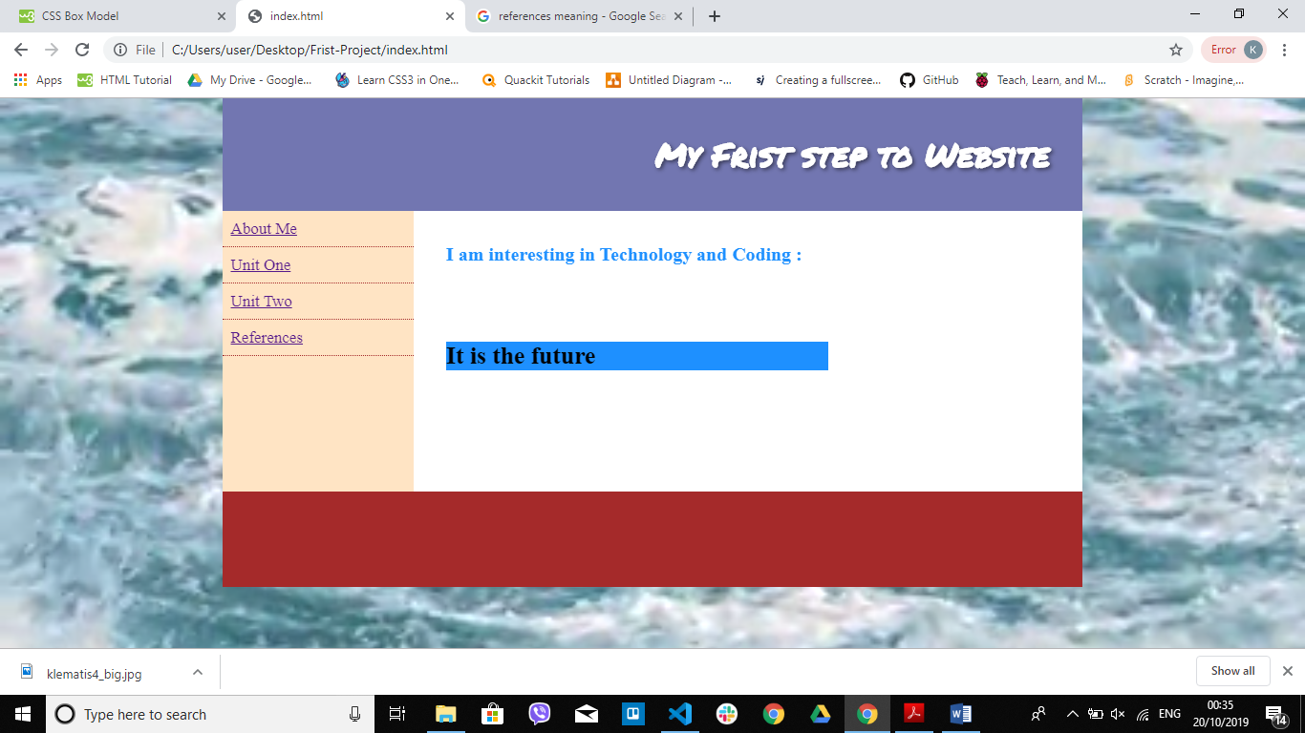

It has some information about me, video background, links to the other pages

Next page: linked with three pages with nice video and pictures background

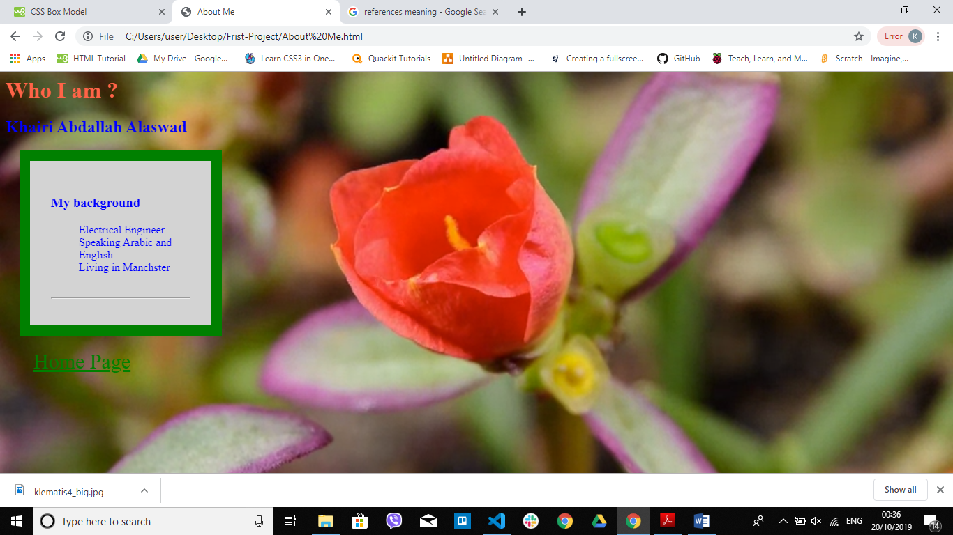

Outcomes pages : they are pages have the information for this project

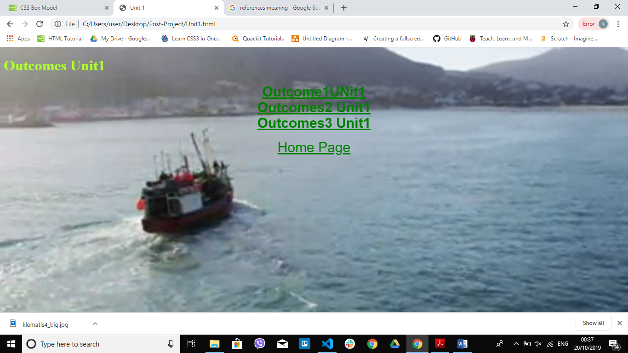

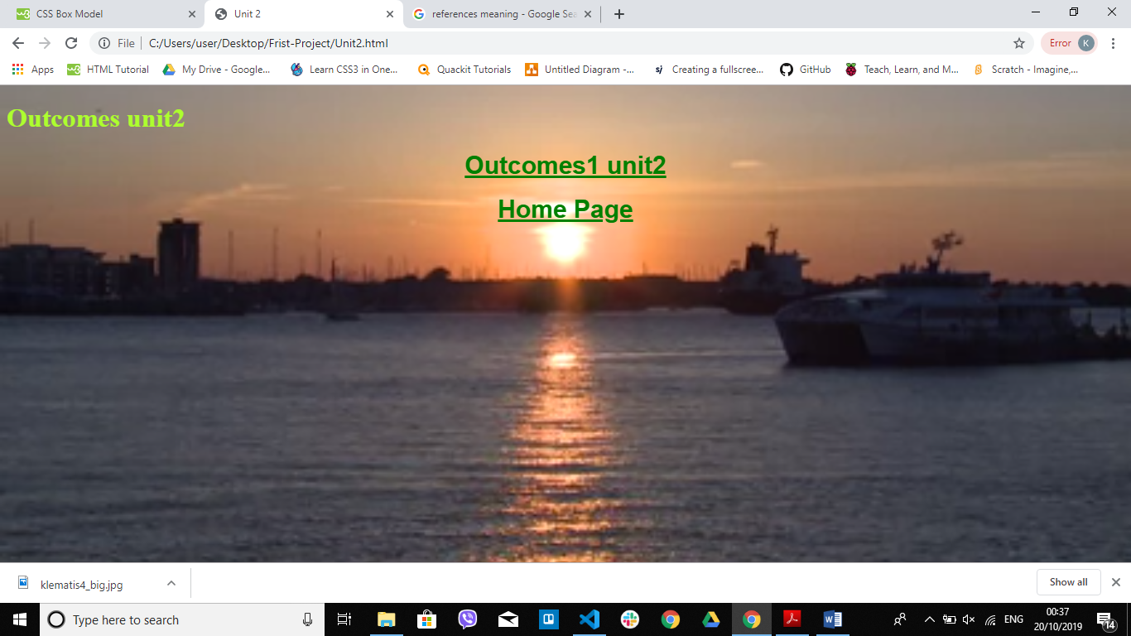

Excluding

Therefore, these are the outcome of the units

1.6 “*Web accessibility* basically means that people with disabilities can use the Web. More specifically, web accessibility means that people with disabilities can perceive, understand, navigate, and interact with the Web”. “<http://uiaccess.com/understanding.html#whatis>

We need to think and keep enation of any detail to:

“Some people cannot use their arms or hands

Some people with tremors and older people with diminishing fine motor control can use a keyboard, but not a mouse.

Some people cannot see at all and use a screen reader that reads aloud the information in the web page.

Some people have blurry vision and cannot read text unless it is very large.”

These points and may more we have to take them in our account when for design websites

1.7

**.AVI — Audio/Video Interleaved**

**.CSS — Cascading StyleSheet**

**.DOC — Microsoft Word DOCument**

**.EXE — EXEcutable file**

**.GIF — Graphics Interchange Format***.*

**.HTML/ .HTM — HyperText Markup Language file**

**.JPG/ .JPEG — Joint Photographic Experts Group file**

**.MIDI/ .MID — Musical Instrument Digital Interface**

**.MP3 — MPEG Layer 3 sound file**

**.MPEG/ .MPG — Motion Picture Experts Group file**

**.MOV/ .QT — QuickTime MOVie**

**.PDF — Portable Document Format**

**.PNG — Portable Network Graphics**

**.RAM — Real Audio Movie**

**.RAR — RAR archive**

**.TIFF — Tagged Image File Format**

**.TXT — TeXT file**

**.WAV — WAVe sound file**

**.ZIP — ZIPped file**

This filetypes very important when we need to link webpage, images, videos and so on.

I divided them like these:

Main Page

Unit Two

About me

Unit One

2.5

3.4

3.3

3.2

3.1

2.4

2.3

2.2

2.1

1.7

1.6

1.5

1.4

1.3

1.2

1.1

Out come1

Outcome3

Outcome2

Outcome1

[www.copyright.gov](http://www.copyright.gov/).

<https://project-management.com/five-factors-that-lead-to-successful-projects/>

<https://thedigitalprojectmanager.com/project-management-skills/><https://www.projectmanager.com/blog/network-diagrams-free-tools>

<https://www.projectmanager.com/blog/network-diagrams-free-tools>

<https://www.businessupnorth.co.uk/the-challenges-digital-professionals-are-facing-why-digital-projects-fail/>

<https://www.interruptdelivers.com/themash/what-is-risk-in-a-digital-project-and-why-should-i-care>

<https://wpcurve.com/trello-for-project-management/>

<https://zapier.com/blog/how-to-use-trello/>

<https://www.w3.org/WAI/standards-guidelines/wcag/>

<https://accessibility.blog.gov.uk/2016/05/16/what-we-mean-when-we-talk-about-accessibility-2/>

<http://uiaccess.com/understanding.html#whatis>

<https://en.wikipedia.org/wiki/General_Data_Protection_Regulation>

<https://www.zdnet.com/article/gdpr-an-executive-guide-to-what-you-need-to-know/>